KRAS Kickers Title Page

Ying Zhou
Emily Tran
Chris Conneran
Daniel Brannock

Table of Contents
Table of Contents 2
Executive Summary 3
Current System 4
Recommendations for New System 5
Implementation Plan 6
Appendix 7
Appendix [Internal] 8
Models 8
Ongoing Concerns 8
Plan Presentation 8
Lessons Learned 8

Executive Summary
[Point person: Daniel]

Background
KRAS Kickers is a patient-driven nonprofit intended to serve the community of people impacted by cancers linked to the KRAS oncogene. Their mission is focused on democratizing knowledge about KRAS cancers, sharing recent research and resources, advocating for patients, and promoting science and survivorship. They do not fund research; rather, they educate, empower, and engage with patients and caregivers as they navigate the rapidly advancing treatment landscape available to those with KRAS cancers. The organization is growing quickly and needs a new system for managing and coordinating volunteerism.

Current State

Proposed State

Implementation Plan

Current System
[Point person: Ying]
Overview
To understand the current volunteer coordination and engagement system used by KRAS Kickers, our team modeled the workflow based on interviews with stakeholders and observations of existing processes. We selected a workflow model to represent the current system, as it clearly outlines the operational sequence, roles, and information flows involved in volunteer recruitment, assignment, and project support.
Current Workflow Model
Workflow for Volunteer Coordination (Current State)
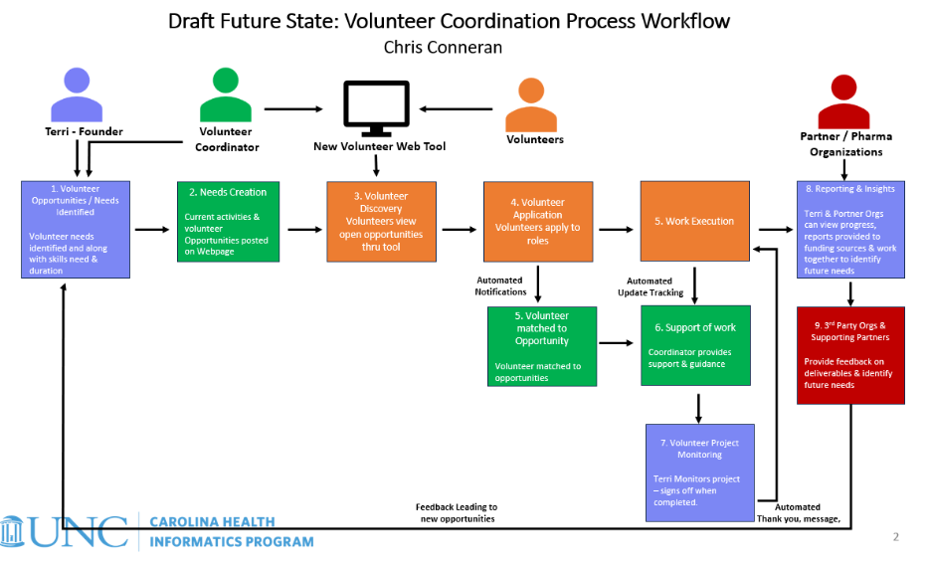
The current workflow illustrates how volunteer needs are identified, posted, and fulfilled within the organization. The process begins when the founder identifies volunteer needs and the volunteer coordinator posts available opportunities. Volunteers then review and apply for roles, after which the coordinator evaluates applications, assigns volunteers, and monitors project execution. Progress updates and feedback are shared between volunteers, the coordinator, and partner organizations, supporting ongoing communication and quality assurance.
This model highlights both automated and manual touchpoints, showing where technology assists coordination (e.g., posting opportunities, automated notifications) and where human oversight ensures successful engagement (e.g., reviewing applications, providing ongoing support).
Information Sources
This workflow reflects combined insights from:
- Interview with Terri Conneran, KRAS Kickers Founder
- Interview with Patty McConnell, KRAS Kickers Event Coordination
- Interview with Hannah Conneran, KRAS Kickers Content Manager
- Interview with Hope Given, KRAS Kickers Patient Outreach
- Input and process knowledge from Chris Conneran, based on existing operations and research on volunteer coordination practices in similar nonprofit organizations
Rationale for Using Workflow Modeling
We chose the workflow model because it clearly demonstrates how the current volunteer system functions, where communication and coordination occur, and where bottlenecks or inefficiencies may arise. By visually mapping the process, we are able to:
- Identify inefficiencies in manual steps (e.g., volunteer matching and follow-up)
- Understand key stakeholder roles and system dependencies
- Recognize opportunities for improved automation and data tracking
- Provide a structured foundation for designing system enhancements
This workflow also allows us to iteratively refine our understanding of the system. As we gather feedback and continue our analysis, the model can be updated to better reflect process realities and guide recommendations for the future system design.

Recommendations for New System
[Point person: Emily]
Our team came together and suggested four possible recommendations for a new volunteer system that will improve volunteer screening, management, and communication.
Recommendation 1: Hiring of a Volunteer Coordinator and Volunteer Management App
GivePulse is a volunteer management app that helps organizations manage their volunteers with ease. Organizers can send out messages, whether it be to everyone or specific subgroups. In addition,
Due to the fact that Terri, the Founder, has a packed schedule of webinars and meetings that often require travel, she lacks the time to be able to coordinate and manage volunteers every day.
Recommendation 2:
Recommendation 3:
Recommendation 4:

Implementation Plan
[Point person: Chris, everyone contributing]

Appendix

Appendix [Internal]
[Point person: Daniel]

Models

Previous Website Mockups

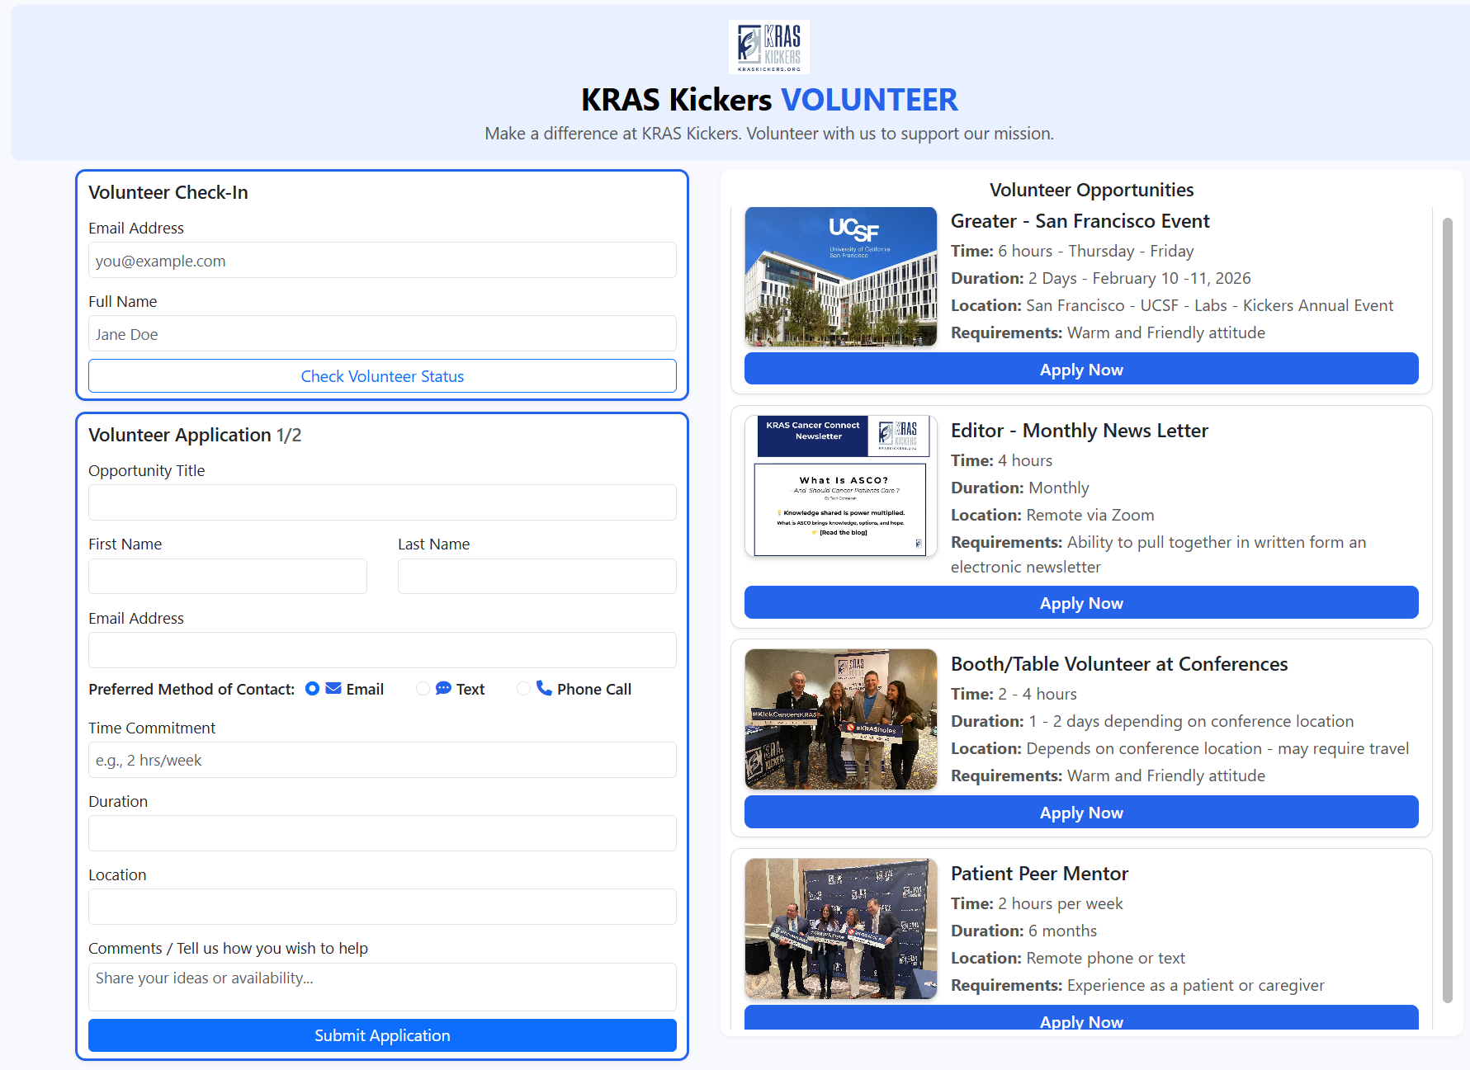

Ongoing Concerns

Plan Presentation

Lessons Learned

Group task: Project report (due: 12/01/2025 by 11.55pm)
Group task: Final Project Presentation (11/19/2025)
Instructions and Sample Outline for the Project Report:
1. Title Page
Project name, author(s), date.
2. Table of Contents
A list of report sections.
3. Executive Summary (required)
A summary of the entire report, not to exceed 2 pages. This section should give a general overview of the entire proposal, without providing specific details. An upper-level manager might read this section just to get an idea of what you've done. A client who will be responsible for implementing your proposal might read this to get a quick orientation before diving into the details of your proposal, or may skip this section entirely. Remember that this is a summary; you will be repeating information from your full proposal. There should not be information given in this section that does not appear in the rest of the proposal, except for material in the Team Appendix.
The summary should include:
- Brief description of old system and problem(s).
- Brief description of method of investigation and design.
- Recommendations: description of new system, in terms of the changes it introduces, and anticipated benefits. (How it will solve problem.)
4. Description of Current System
This section presents your team's findings concerning the current system and system environment (organizational, technical, etc.), the problem and symptoms, and needs and requirements. It presents your team's perspective, which may not necessarily be the same as the client's view. For example, it may seem obvious to you that a high turnover rate contributes to the problem, but the client may not have considered it, and may not even realize how high the turnover rate is. In other words, this is your opportunity to frame the problem.
The description should include:
- Brief narrative description.
- Representation of current system, using/integrating models and techniques discussed in class.
- Choice of specific models depends on type of system and problems or issues that you wish to highlight.
5. Recommendations for New System
In addition to laying out your recommendations, you should also describe how you developed the ideas (e.g., standards guidelines, product surveys, interviews), and justify each recommendation. If you provide a choice of proposals (for example, a bare-bones version and a deluxe version), lay out the advantages and disadvantages of each. If there are parts of the problem that your proposed system does not solve, explain what will remain, and why.
The recommendations should include:
- Narrative summary of changes introduced in new system.
- Model of proposed system, using/integrating models and techniques discussed in class. This should provide a complete and specific description of the proposed system. Choice of specific models depends on type of system and features you wish to highlight, or that require detailed specification.
6. Implementation Plan for New System (required)
This section should lay out what is required to implement your recommendations, and should provide sufficient information for a manager to decide if this is a feasible idea, and if so, how to prioritize it in relation to other projects. It should describe the activities needed for implementation, along with estimates of the time, people, equipment and costs required. This might be where a manager would turn next, after reading the Executive Summary, to see if the implementation plan is at all feasible for the organization.
7. Client Appendix
Use this optional section for reference materials, coding or technical details, or other information that is not likely to be of immediate interest to your client. Examples include a glossary of terms, detailed product specifications, or a script for data cleaning.
8. Team Appendix (required)
The previous sections should be appropriate for your client's use. This required section, in contrast, is specifically for our use as part of your class learning experience. It should demonstrate work you did that is not included in the client's sections, as well as your thoughts and reflections on the project and the systems analysis experience.
This appendix should include:
- Any models the team used for internal purposes. These might include strong competing models for which you still see some advantages, or cultural models that helped you understand the client better.
- Any lingering issues or concerns you have about your proposed system.
(REQUIRED) Your plans for presenting your proposal to the client.
(REQUIRED) Lessons learned. As a team, how do you assess your team's performance and results? What were your strengths and weaknesses? What would you do differently if you had it to do over again? What lessons can you carry with you for the next project? You should reflect both on the specific project, and on what you've learned about systems analysis in general.

